Project Report

Name: Md Bellal Mollah
ID:2024-3-60-128
Course Code: 200
Course Title:Computer Aided Engineering drawing.
Section: 02
Semester: Summer-25
Submitted to : SDIS

2D SCREENSHOT.
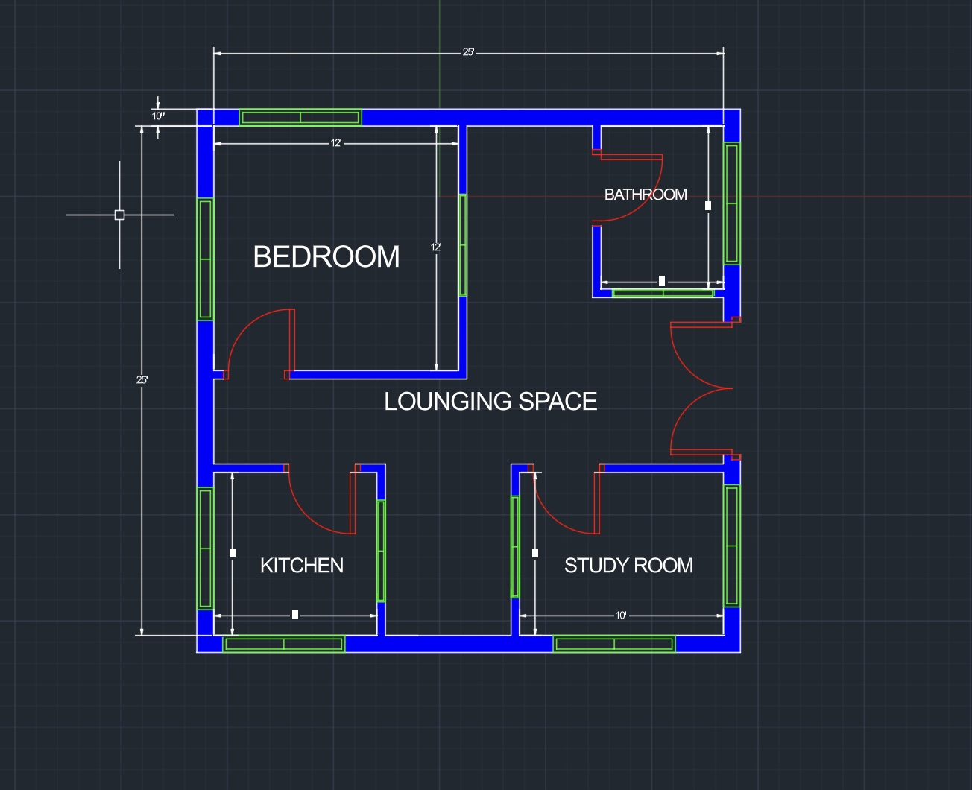

3D SCREENSHOT.

3D WITHOUT ROOF.
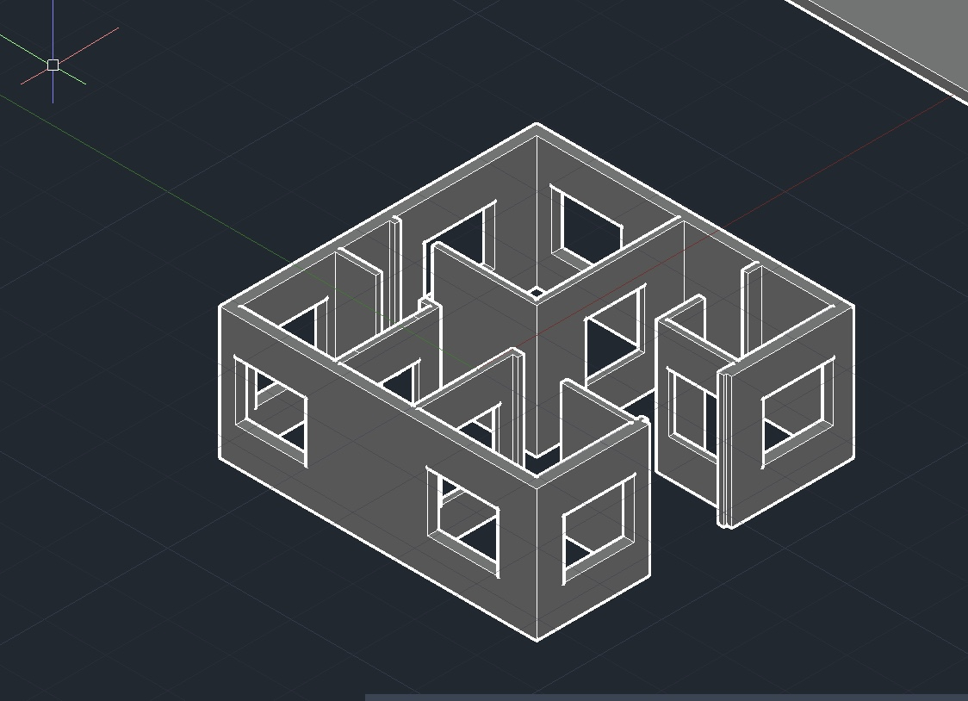

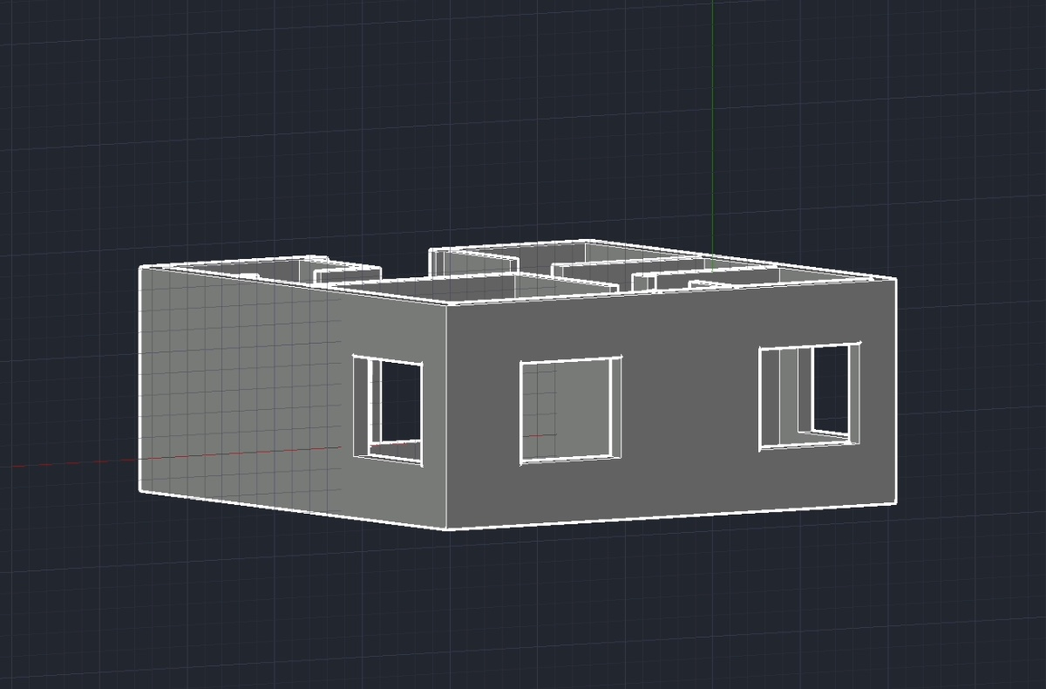
3D WITHOUT ROOF.
